**Note:** After countless hours of working and debugging this, this is as far as I was able to get to. I cannot thank TAs Felipe and Chris enough for helping me out with this enormous project! Chris even changed my scrap_mars.py file and app.py file, but unfortunately, I was unable to change the display. I just could not get my featured image, weather tweet, and hemisphere images to display under my section titles. Just for added substance, I copied and pasted my html fact table under the “Mars Planetary Facts” section. If I had more time, I would’ve formatted that better, but for now, this sufficed. For now, I am submitting this as is, along with my files and my html output file. However, I am relentless and at a future point, would like to come back to this project and complete it for good: get the rest of the information to display.

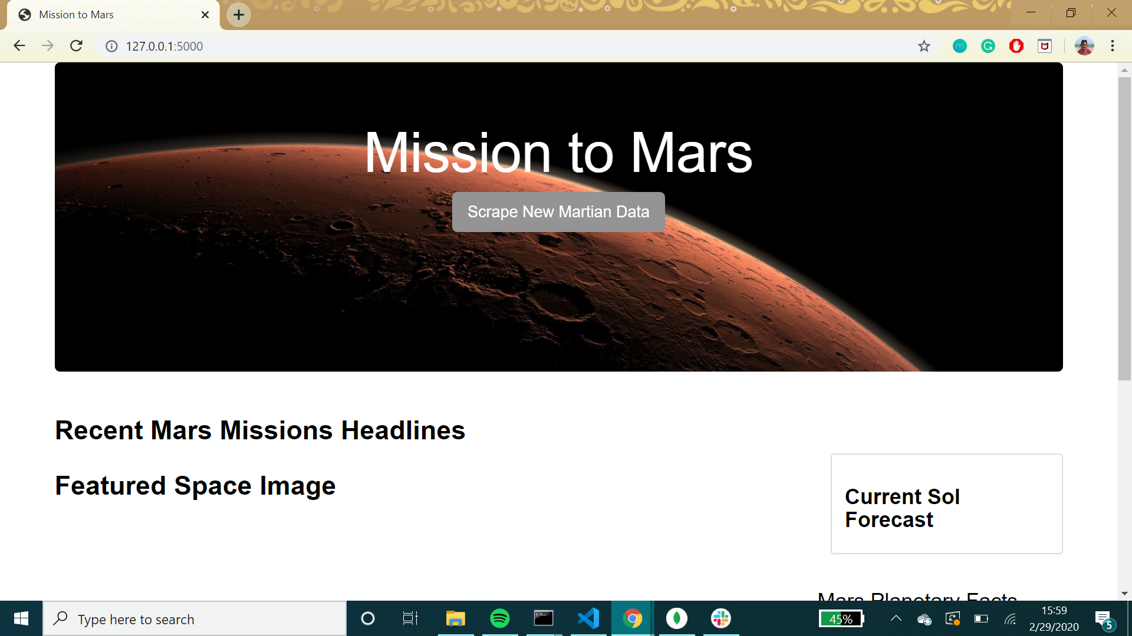

After I opened it from the folder:

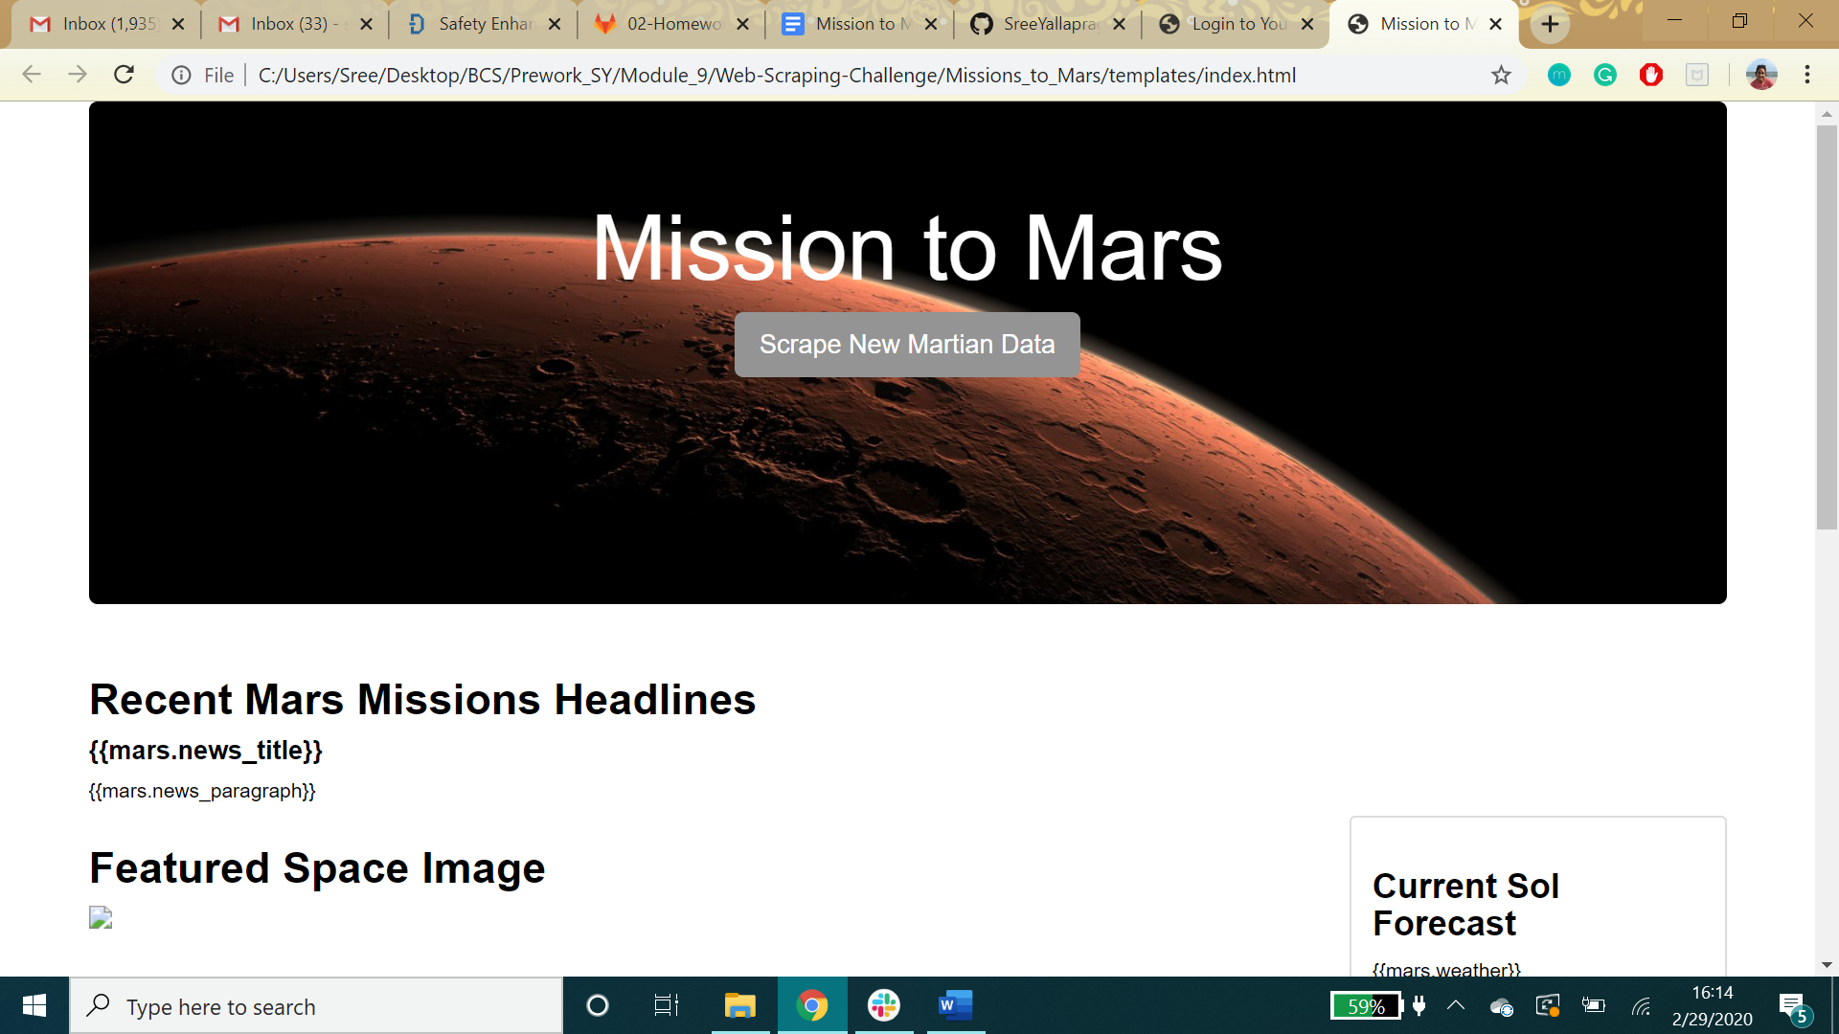

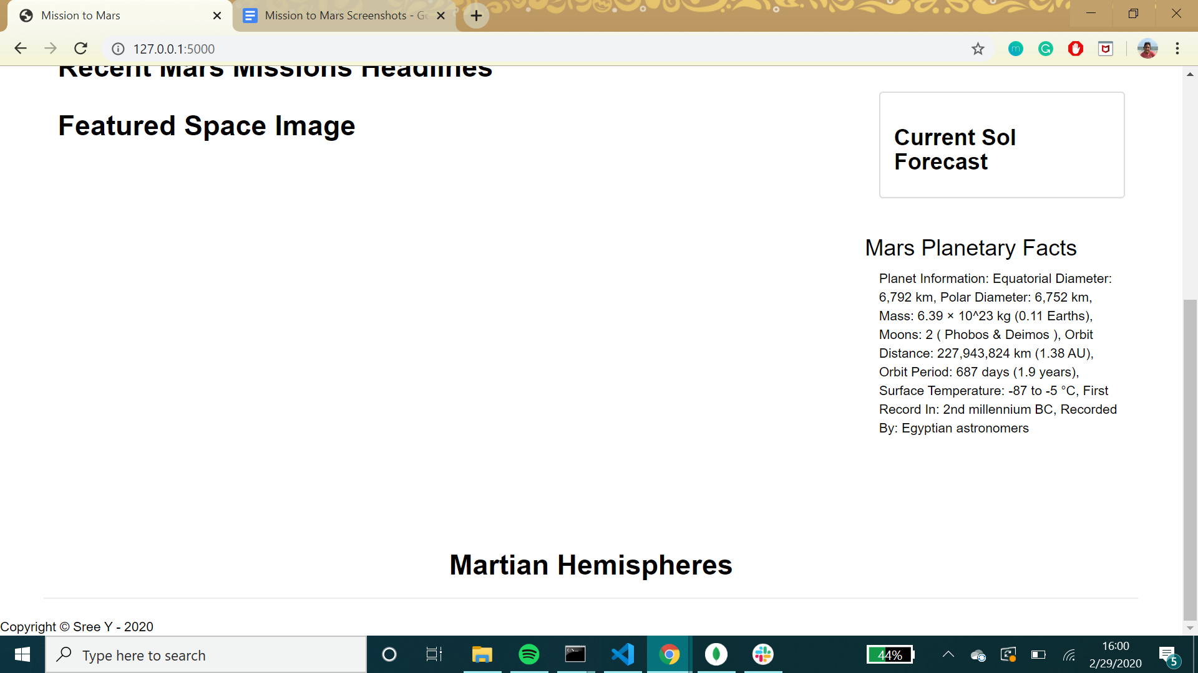

After opening from explorer:

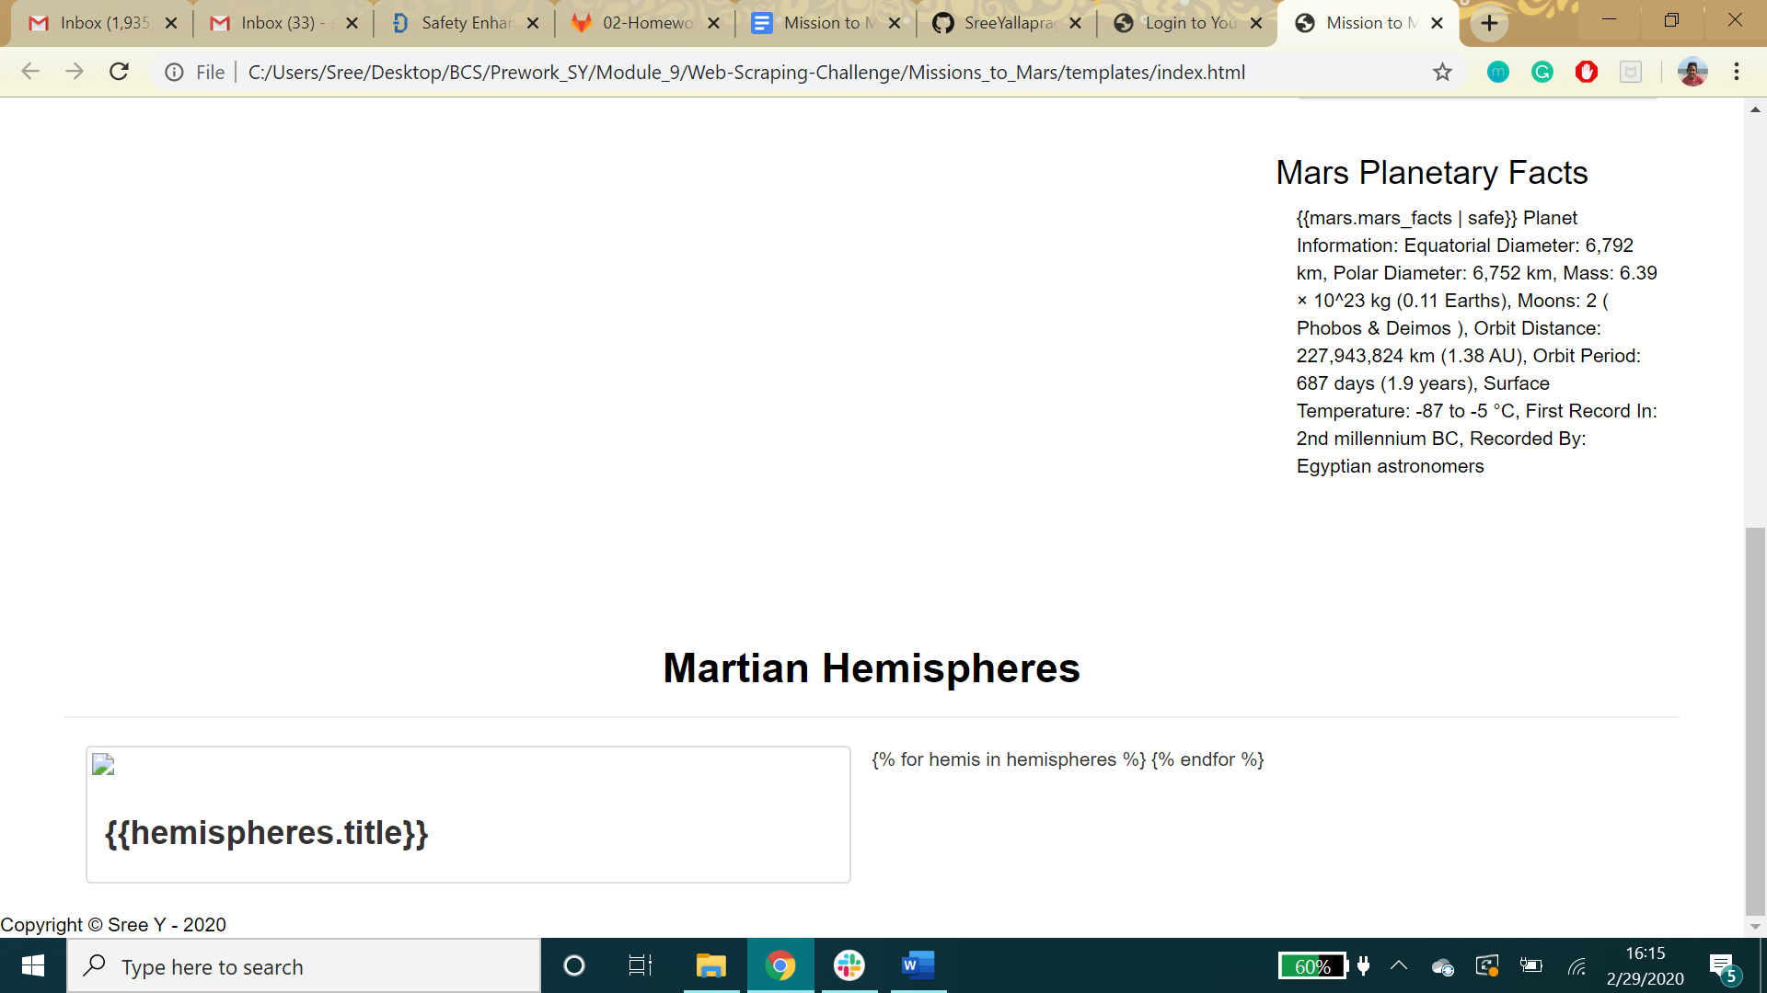

HTML File Screenshot:

